

北京理工大学

本科生毕业设计（论文）开题报告

Code Quest: AI-Supported Gamified Web Learning System

学 院 ：计算机学院
专 业 ：计算机科学与技术
班 级 ：07112006
姓 名 ：许安康
指导教师 ：赵丰年

毕业设计（论文）开题报告评审表
姓名 |  | 许安康 |  | 学号 | 1820221137 | 班级 | 07112006 | 专业 |  |  | 计算机科学与技术
导师 |  | 赵丰年 |  | 校外导师（职称） |  |  |  | 校外导师单位
论文选题 | 题目名称 |  |  | 基于人工智能的科学探索教育游戏的设计与实现
 | 题目性质 |  |  | 软件开发（ √ ） 理论研究（ ）
 | 题目来源 |  |  | 结合科研 （ √ ） 结合生产实际（ ）  结合实验室建设（ ） 自拟题目 （ ）
评审组成员 | 姓 名 |  |  | 职 称 |  | 工作单位及职务 |  |  | 签 字
评  审  意  见 | （含：选题意义；选题是否满足毕业要求；技术方案是否可行；进度安排是否合理等）
成 绩
评审组长签字： 年 月 日

1. Graduation project topic content

Title: Code Quest Frontend: AI-Supported Gamified Web Learning System

Introduction

In today's digital era, traditional methods of learning are changing to fit new technologies and ways of doing things. Gamification is one of the best and most fun ways to educate difficult topics like web development. This thesis presents an innovative learning platform aimed at enabling beginners to proficiently acquire frontend development techniques, including HTML, CSS, and JavaScript, through the integration of gamified components and a user-friendly interface.

The main goal of the "Code Quest Frontend" platform is to make learning fun, interactive, and immersive. Users are more likely to finish challenges when they can earn stars, achievements, and leaderboard rankings. This makes them more engaged and keeps them coming back for more. This method makes learning entertaining and game-like, and it encourages users to move forward, study, and master coding at their own pace.

HTML, CSS, and JavaScript are the main languages taught on this platform. These are the basic building blocks of web development. HTML is the language that makes up the web, setting the structure and parts of a webpage. CSS is in charge of styling, which lets students make their websites look good. Finally, JavaScript adds dynamic and interactive features that let users add features to web sites. If you want to start a career in web development, these three languages will provide you a solid base.

With a gamified and AI-enhanced method, learners will not only gain technical skills, but they will also be encouraged to keep getting better. Using interesting pictures, instant feedback, and rewards for achievements keeps students interested and sure of their progress, which will eventually lead to mastery of frontend programming technology.

1.2 Basis for Topic Selection
The "Code Quest Frontend: AI-Supported Gamified Web Learning System" was selected based on several important aspects that correspond with contemporary educational needs and technological developments.
- Growing Demand for E-Learning: As online education becomes more popular, there is a greater need for effective and interesting web development teaching platforms. Gamified learning experiences have been shown to be more interesting and help learners study more effectively, making them an excellent tool for teaching frontend technology.
- Gamification in Education: Gamification is well-known for its capacity to improve motivation, user engagement, and learning results. By incorporating gaming features such as achievements, leaderboards, and awards, students are motivated to finish classes, face difficulties, and track their progress, fostering continuous growth.
- AI Advancements for Personalised Learning: The use of AI-driven features like personalised learning routes and customisable difficulty improves the learning process. AI enables the system to give personalised content, ensuring that learners face challenges that are suitable for their ability, keeping them motivated without feeling overwhelmed or distracted.
- Frontend Development abilities: HTML, CSS, and JavaScript are essential abilities for web development. With the increased demand for web developers in the technology industry, mastery of these languages has become increasingly significant. This project seeks to build a platform where beginners may learn important skills in a hands-on and interactive setting, preparing them for success in the field of web development.
- Engaging Learning Experience: The topic blends cutting-edge technology like gamification and artificial intelligence with hands-on coding activities to create an engaging, user-friendly platform that motivates students to learn via doing. Adding AI features gives each student personalised coaching, which makes the learning process more flexible and effective for everyone.

2. Research Program

The research programme for this project is centred on the creation and implementation of a gamified web learning system that incorporates AI-driven individualised learning paths for frontend development. The major purpose is to investigate and utilise innovative educational technologies such as gamification, artificial intelligence, and modern web development tools to provide a dynamic and engaging learning environment for novices.

The research programme will focus on both the technological requirements of constructing the platform and the educational problems of creating an engaging educational experience. The investigation will include a review of existing e-learning solutions, finding gaps in current offerings, and evaluating the effectiveness of the gamified AI-enhanced learning system.

2.1 The Main Task
The primary goal of this project is to design, develop, and implement the "Code Quest Frontend" platform, which is a gamified e-learning system for frontend development. The platform will teach users important web development technologies including HTML, CSS, and JavaScript through interactive coding challenges, quizzes, and hands-on activities.

2.1.1 System Architecture.
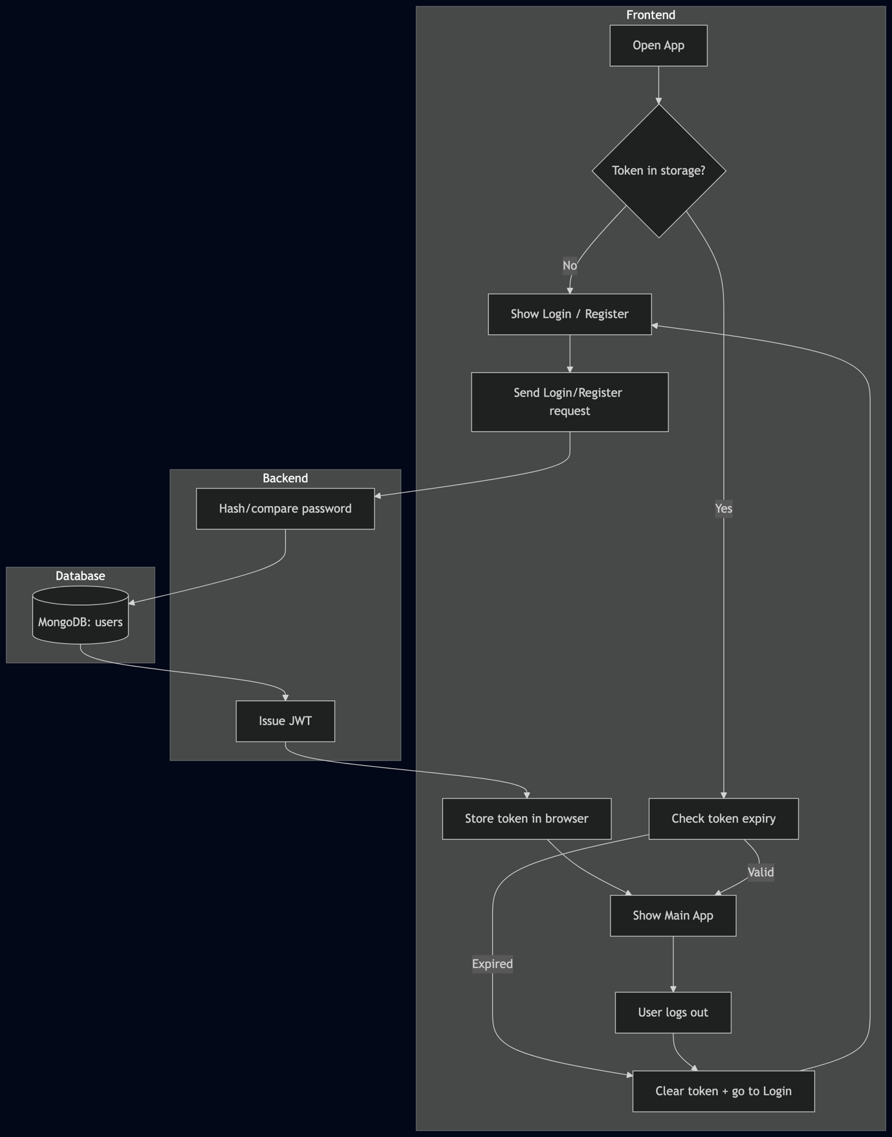

2.2 System Design and Development
The system design and development phase focuses on developing the "Code Quest Frontend" platform's architecture, interface, and major features to guarantee that learners have an engaging, interactive, and user-friendly experience. The main objectives are:
- User Interface (UI) Design: Create a clean, intuitive, and visually appealing user interface that is simple to use for beginners. This will contain wireframes, mockups, and prototypes to ensure that the platform's layout is both functional and visually appealing.
- Gamification Features: Use game-like elements such as achievements, badges, leaderboards, and reward points to motivate students. These features will be strategically placed throughout the learning process to instil a sense of progress and accomplishment.
- Learning Flow and Navigation: Create a seamless, logical flow for the students, guiding them through coding exercises, challenges, quizzes, and real-world projects. The platform will provide a step-by-step progression with explicit milestones, allowing learners to monitor their progress.
- Interactive Components: Create hands-on coding assignments that imitate real-world tasks, allowing students to apply what they have learned in a practical situation. This contains interactive tutorials and dynamic feedback to help learners complete their coding tasks.
- Adaptive Learning Pathways: Create an AI-driven system that changes learning content based on individual success, ensuring that learners are adequately pushed but not overwhelmed. This will also offer tailored recommendations and automated difficulty modifications.

2.3 Technical Implementation
The technical implementation phase focuses on identifying and integrating the tools and technologies required to bring the platform to life. The goal is to deploy current, scalable, and efficient technology to ensure that the platform is reliable, fast, and capable of providing a consistent learning experience. Key technologies and their functions include
- Frontend Development:
  - React.js: The JavaScript library will be used to create the platform's interactive user interface. Real-time feedback and interactive education require dynamic content updates and a pleasant user experience, which React enables.
  - Tailwind CSS (v4) + Radix UI + MUI + Emotion: Styling uses Tailwind utilities, with UI primitives from Radix and MUI components styled via Emotion.
- Backend Development:
  - Node.js with Express.js: Node.js will be utilised for server-side logic, while Express.js will be used to speed up the creation of backend APIs for user authentication, data management, and frontend-backend communication.
  - MongoDB with Mongoose: User data, auth records, and app state persist in MongoDB via Mongoose models.
  - JWT + bcrypt.js: Authentication uses JWTs and password hashing.
- Artificial Intelligence (AI) Integration:
  - TensorFlow.js: This JavaScript library will be used to enable AI capabilities like customised instruction routes and adaptive difficulty levels. TensorFlow.js will process user data and make intelligent recommendations, ensuring that the learning experience can be customised to each individual's needs.

  - Machine Learning Models: Custom AI models will be built to monitor user performance, identify learning patterns, and deliver real-time feedback, making the platform more engaging and responsive.
- Gamification Tools:
  - Custom-built Gamification System: A unique backend system will keep track of users' achievements, points, badges, and leaderboard status. This technology will work directly with the platform's interface, providing real-time updates on user progress and prizes.
- Containerisation and Deployment:
  - Docker: Docker will be used to containerise the application, guaranteeing that it works successfully across all environments (development, testing, and production). This simplifies deployment and increases the platform's scalability.
- Testing and Optimisation:
  - Unit Testing: The system will be tested using Jest and Mocha to ensure the functionality of individual components, such as the user interface, backend APIs, and AI algorithms.
  - Performance Testing: Tools like Apache JMeter will be used to measure the performance of the platform, ensuring fast load times, responsiveness, and a smooth user experience.

2.3.1 Technical Problem
- Scalability and Performance:
  - Problem: As the platform expands and more users interact with it, performance and scalability become critical issues. With many users accessing the platform, the backend needs to efficiently handle user authentication, data persistence, and real-time updates without compromising performance.
  - Solution: The backend will be constructed with Node.js and Express.js, which are highly scalable and capable of managing large quantities of ongoing queries. MongoDB will be chosen because of its flexibility and horizontal scalability, allowing the platform to scale effectively as the data grows. Additionally, using Docker for containerisation will assist in maintaining consistency between environments while also improving scalability by allowing the program to scale horizontally.
- Real-Time Interaction and Feedback:
  - Problem: Providing real-time feedback for coding exercises and gamified aspects, such as updating user progress, achievements, and XP, poses a synchronization difficulty between the frontend and backend.
  - Solution: To overcome this, the platform will use asynchronous communication through REST APIs. WebSocket or related technologies may be used in the future to provide real-time updates, guaranteeing that consumers receive rapid feedback on their activities. Additionally, Redux will help manage the state and guarantee that frontend modifications are synchronised with backend data.
- AI Integration and Personalisation:
  - Problem: Incorporating AI-driven features for personalised learning pathways and adjusting the complexity of problems in real time might be challenging. It entails analysing user data and making real-time adjustments based on learner behaviour, which may result in latency or data consistency difficulties.
  - Solution: To simplify the complexity of local machine learning models, the platform will implement API-based AI integration (for example, through OpenAI). The backend will evaluate user input and send API requests to the AI provider to provide recommendations or feedback. To ensure smooth integration, data storage and processing will be handled easily with MongoDB and Mongoose, which can easily accept changing user data and AI system feedback.
- Data Quality and Accuracy:
  - Problem: The platform's efficacy is dependent on the correct recording of user progress, achievements, and learning milestones. If the data is inconsistent or wrong, it could risk the user experience and gamification features like XP tracking, leaderboards, and achievement unlocking.
  - Solution: To ensure data consistency, the backend will use comprehensive validation and error-handling techniques for incoming data. Mongoose models will use rigorous schemas to maintain data integrity. Furthermore, periodic checks and synchronization with the MongoDB database will be carried out to ensure the accuracy of stored data and make any necessary changes.
- Security and Authentication:
  - Problem: The security of user data, particularly sensitive information such as login tokens and personal progress data, is critical to the platform's success. Insecure authentication or data breaches may harm user confidence and platform integrity.
  - Solution: JWT (JSON Web Tokens) will be utilised for secure user authentication, ensuring that sensitive information, such as passwords, is never stored directly. Passwords will be hashed with bcrypt.js before being stored in the database to improve security. In addition, encryption and secure HTTP (HTTPS) will be utilised to protect data during transmission.
- User Engagement and Retention:
  - Problem: Keeping people engaged and motivated throughout their learning journey is a significant problem. Without appropriate incentives and progress tracking, users may lose interest and exit the platform.
  - Solution: To address this, the site will use gamification features like XP points, leaderboards, and achievement badges. These aspects will be developed to give consumers ongoing feedback, a sense of accomplishment, and motivation to perform tasks. The system will also leverage AI-driven recommendations to keep learners engaged with relevant, personalised information.

2.4 Research Objectives that are expected to be achieved
The final deliverables for the "Code Quest Frontend: AI-Supported Gamified Web Learning System" will include the following components to ensure that the project is not only functional but also well-documented and ready for future academic review:
- Working Software System or Prototype:
  - A fully comprehensive web-based e-learning platform featuring gamification, AI-powered individualized learning routes, and interactive coding challenges. The system will teach users HTML, CSS, and JavaScript through interactive exercises, real-time feedback, and gamified aspects like XP points, achievements, and leaderboards.
- Source Code:
  - The platform's whole source code, built with technologies such as React.js, Node.js, Express.js, MongoDB, and TensorFlow.js. The code will be well-organized, commented, and structured to facilitate learning and future growth.
- Software Documentation:
    - The platform's whole source code, built with technologies such as React.js, Node.js, Express.js, MongoDB, and TensorFlow.js. The code will be well-organized, commented, and structured to facilitate learning and future growth.
- Thesis Report:
  - A comprehensive thesis report outlining the complete development process, including:
    - The motivation behind the project and the problem it aims to solve.
    - A thorough review of related work, including the integration of gamification and AI in educational platforms.
    - Design decisions, challenges encountered, and solutions implemented.
    - Results of testing and optimization.
    - A discussion of the project’s effectiveness in enhancing learning experiences for users.
- Foreign Literature Translation:
  - A translation of relevant international literature on gamification, artificial intelligence in education, and web-based learning. This will comprise essential research papers, publications, and academic materials that help to build the project's theoretical and technological foundation. The translated documents will serve to offer an international context for the project's development and implementation.

2.4.1 Innovations
- AI-Driven Personalization: Implementing AI to change learning paths and recommend content based on individual user success, resulting in a more personalized learning experience.
- Gamification: Using gamified aspects such as XP, achievements, and leaderboards to inspire users and increase engagement.
- Real-Time Feedback: Providing rapid feedback through interactive coding challenges to improve user learning and retention.
- Seamless Integration: Ensure seamless backend and frontend integration for data management, real-time tracking, and personalized advice.

3. Project plan schedule

Time Period | Task
2026.02.10 – 2026.03.01 | Familiarise with frontend technologies (React.js, TypeScript, Vite), and collect data for project.
2026.03.01 – 2026.03.14 | Design the system architecture and plan the gamification and AI features
2026.03.15 – 2026.04.01 | Develop backend system (Node.js, Express.js, MongoDB), and integrate gamification elements
2026.04.01 – 2026.04.14 | Implement AI-driven personalized learning paths and integrate with the backend
2026.04.15 – 2026.05.01 | Design and implement frontend visual interface (React.js, Tailwind CSS, MUI components)
2026.05.01 – 2026.06.10 | System testing, debugging, and performance optimization; finalize thesis and related documents

Reference
- Deterding, S., Dixon, D., Khaled, R., & Nacke, L. (2011). From game design elements to gamefulness: Defining gamification. Proceedings of MindTrek, 2011.
- Hamari, J., Koivisto, J., & Sarsa, H. (2014). Does gamification work? A literature review of empirical studies on gamification. HICSS, 2014.
- Kapp, K. M. (2012). The gamification of learning and instruction. Pfeiffer.
- Csikszentmihalyi, M. (1990). Flow: The psychology of optimal experience. Harper & Row.
- Anderson, R., & Krathwohl, D. R. (2001). A taxonomy for learning, teaching, and assessing. Longman.
- Guo, P. J. (2013). Online Python Tutor: Embeddable web-based program visualization for CS education. SIGCSE, 2013.
- Holzinger, A. (2016). Interactive machine learning for health informatics: When do we need the human-in-the-loop? Springer.
- Nielsen, J. (1993). Usability engineering. Morgan Kaufmann.
- Fessakis, G., Gouli, E., & Mavroudi, E. (2013). Problem solving by 5–6 year old children in a computer programming environment: A case study. Computers & Education, 60(1), 115–125.
- W3C. (2014). HTML5 specification. World Wide Web Consortium.
- Kassenkhan, A. M. (2025). Gamification and Artificial Intelligence in Education: A review of innovative approaches to fostering critical thinking. ResearchGate. https://www.researchgate.net/publication/392357532_Gamification_and_Artificial_Intelligence_in_Education_A_Review_of_Innovative_Approaches_to_Fostering_Critical_Thinking
- Wang, J. (2025). Learners' trait competitiveness and leaderboard use in educational gamification. Computers & Education. https://www.sciencedirect.com/science/article/abs/pii/S0360131524002100
- Marengo, A. (2025). Integrating AI and gamification in higher education: Effects on personalized learning. Frontiers in Computer Science. https://www.frontiersin.org/journals/computer-science/articles/10.3389/fcomp.2025.1587040/full
- Gejandran, P., & Abdullah, N. (2024). Gamification in e-learning: Benefits, challenges & future directions. Journal of Logistics, Informatics & Service Science. https://www.aasmr.org/liss/Vol.11/No.2/Vol.11.No.2.06.pdf
- Gómez Niño, J. R. (2024). Gamifying learning with AI to develop 21st-century skills. Tandfonline. https://www.tandfonline.com/doi/full/10.1080/02568543.2024.2421974
- Pradana, F., Setyosari, P., Ulfa, S., & Hirashima, T. (2023). Development of gamification-based e-learning on web design topic. ResearchGate. https://www.researchgate.net/publication/368321947_Development_of_Gamification-Based_E-Learning_on_Web_Design_Topic
- Fortuna, A. (2025). Artificial intelligence in personalized learning: A global review. Social Sciences & Humanities Open. https://www.sciencedirect.com/science/article/pii/S2590291125008447
- Ishaq, K., & Alvi, A. (2023). Personalization, cognition, and gamification-based programming language learning. ArXiv. https://arxiv.org/abs/2309.12362
- Ibisu, A. E. (2024). Development of a gamification model for personalized e-learning. ArXiv. https://arxiv.org/abs/2404.15301

